**Farewell to Piia Vottonen, National Member for Finland**

31/07/2019

Piia Vottonen, who officially took up her duties at Eurojust in August 2015 as the National Member for Finland, has returned to Finland to work as Special Prosecutor for drug crime and organised crime.

Ms Vottonen became a District Prosecutor in 1995, and has specialised in investigations of drug crime and organised crime since 2001. Ms Vottonen is also a member of a group of prosecutors responsible for training drug crime investigators, judges and prosecutors. She is a member of the European Network for Prosecutors for Synthetic Drugs & Precursors (ENPSDP) and a deputy member of the Precursor Network of the Pompidou Group.

Ms Vottonen received a Diploma of Master of Laws from Turku University in 1992. She is returning to Finland to finish her studies for Licentiate of Laws at Helsinki University.

While at Eurojust, Ms Vottonen was a Project Executive of Drug Trafficking Project Team. She ‘opened’ the Finnish Presidency of the EU at Eurojust on 1 July 2019 and attended the Informal Justice Ministers Meeting in Helsinki on 19 July 2019 as part of the Eurojust delegation.

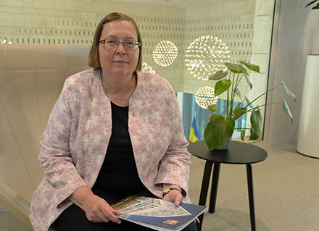Ms Vottonen said: *‘World and criminal activities are evolving fast, which is why judicial collaboration becomes even more crucial to respond to these threats. Working at Eurojust has given me the opportunity to rely easily on this judicial cooperation and helped me a lot in my day-to-day activities. I know where to find the competent judicial authority for obtaining judicial assistance either directly or via Eurojust. One of the key things I will be taking with me from Eurojust is a network of colleagues whom I can ask for assistance in finding the right contact person in his/her country. Eurojust responds quickly to requests for assistance, facilitates the exchange of information across borders and supports national judicial authorities in overcoming legal and practical obstacles. Eurojust also promotes trust and partnership and helps tackle criminal justice across borders. Eurojust is the bridge-maker for judicial collaboration.’*